SQL: Mini Project
Level 1: Basics

1. Retrieve customer names and emails for email marketing
SELECT name,email from customers;
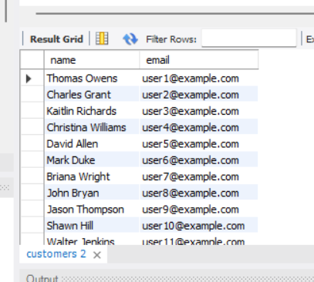

2. View complete product catalog with all available details
select * from products;
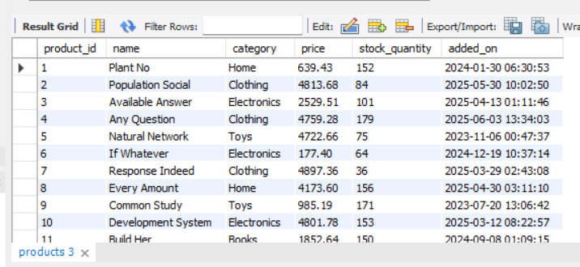

3. List all unique product categories
select distinct(category) from products;
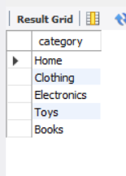
4. Show all products priced above ₹1,000

select name,category,price from products where price>1000;
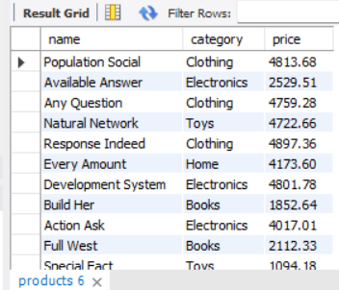

5. Display products within a mid-range price bracket (₹2,000 to ₹5,000)
select name,category,price from products where price between 2000 and 5000 ;
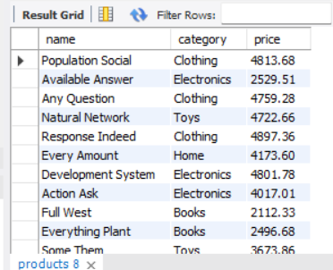
6. Fetch data for specific customer IDs (e.g., from loyalty program list)

7. Identify customers whose names start with the letter ‘A’
select * from customers where name like "A%";
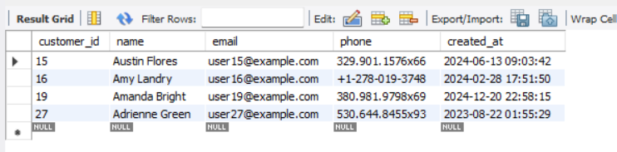

8. List electronics products priced under ₹3,000
select * from products
where price<3000 and
category="Electronics";

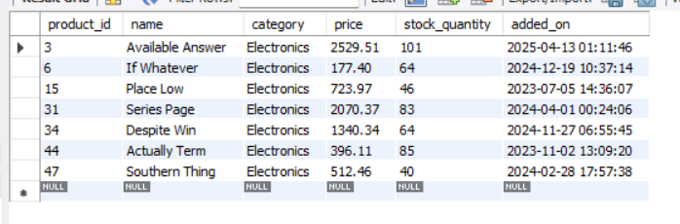
9. Display product names and prices in descending order of price
select name, price from products order by price desc;
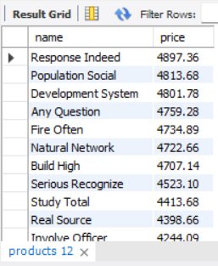
10. Display product names and prices, sorted by price and then by name
select name,price from products order by price asc,name asc;

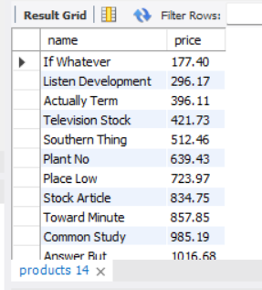
Level 2: Filtering and Formatting
1. Retrieve orders where customer information is missing (possibly due to data migration or deletion)
SELECT
o.order_id,
o.customer_id,
c.name
FROM orders o
LEFT JOIN customers c
ON o.customer_id = c.customer_id
WHERE c.customer_id IS NULL;

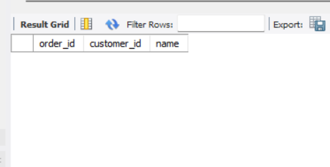

2. Display customer names and emails using column aliases for frontend readability

SELECT
name AS "Customer Name",
email AS "Email Address"
FROM customers;
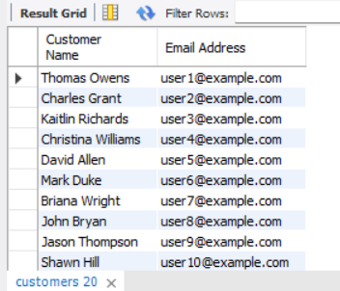
3. Calculate total value per item ordered by multiplying quantity and item price
SELECT
order_id,
quantity,
item_price,
quantity * item_price AS total_value
FROM order_items;
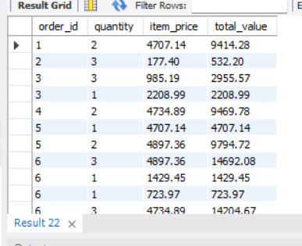
4. Combine customer name and phone number in a single column
SELECT
CONCAT(name, ' - ', phone) AS customer_contact
FROM customers;
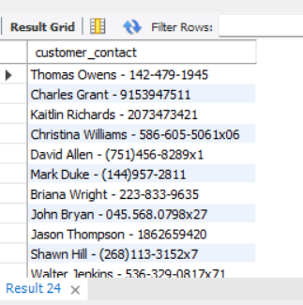

5. Extract only the date part from order timestamps for date-wise reporting
SELECT
order_id,
DATE(order_date) AS order_date
FROM orders;
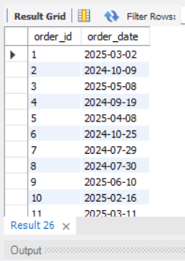

6. List products that do not have any stock left

select name,product_id from products where stock_quantity<1;
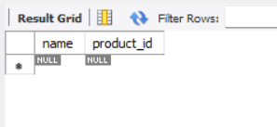
Level 3: Aggregations

1. Count the total number of orders placed
SELECT COUNT(*) AS total_orders
FROM orders;
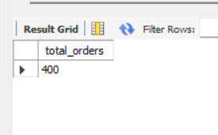

2. Calculate the total revenue collected from all orders
select sum(total_amount) from orders;
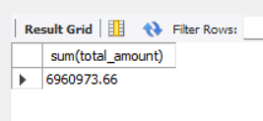

3. Calculate the average order value
select avg(total_amount) from orders;
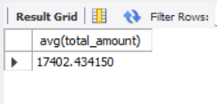
4. Count the number of customers who have placed at least one order
SELECT COUNT(DISTINCT customer_id) AS customers_with_orders
FROM orders;
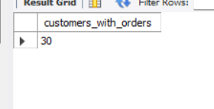
5. Find the number of orders placed by each customer
SELECT
customer_id,
COUNT(*) AS order_count
FROM orders
GROUP BY customer_id;
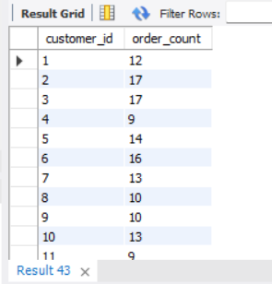

6. Find total sales amount made by each customer
SELECT
c.customer_id,
c.name,
SUM(o.total_amount) AS total_sales
FROM customers c
JOIN orders o
ON c.customer_id = o.customer_id
GROUP BY c.customer_id, c.name;
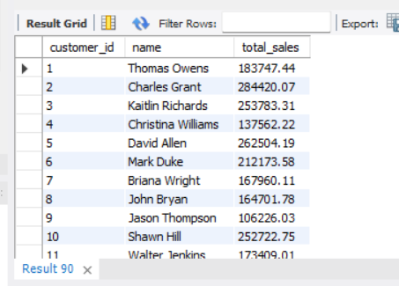

7. List the number of products sold per category
select category ,count(*) from products group by category;
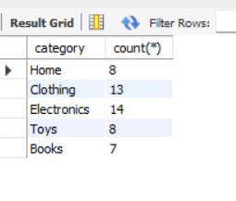
8. Find the average item price per category
select category ,avg(price) from products group by category;
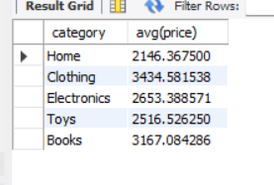
9. Show number of orders placed per day
SELECT
DATE(order_date) AS order_date,
COUNT(*) AS total_orders
FROM orders
GROUP BY DATE(order_date)
ORDER BY order_date;

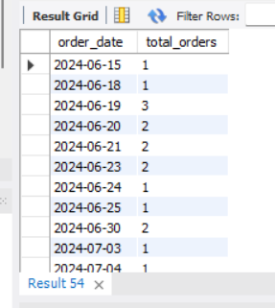

10. List total payments received per payment method
select method,sum(amount_paid) as total_payments from payments group by method;
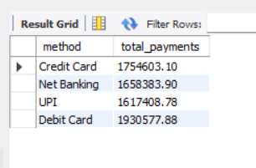

Level 4: Multi-Table Queries (JOINS)
1. Retrieve order details along with the customer name (INNER JOIN)

select customers.name,customers.email,customers.phone,orders.order_id,orders.order_date from customers
inner join orders on customers.customer_id=orders.customer_id;

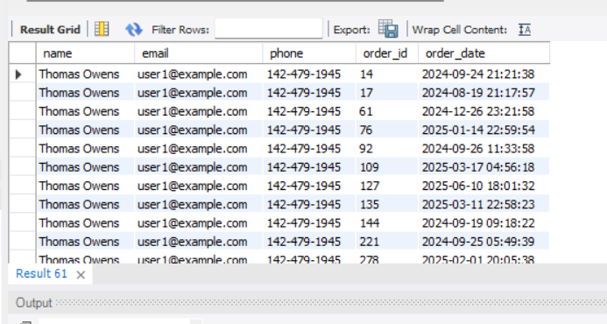
2. Get list of products that have been sold (INNER JOIN with order_items)
select order_items.order_item_id,order_items.product_id,order_items.quantity,orders.order_date,orders.status from order_items
Inner join orders on order_items.order_id-orders.order_id;
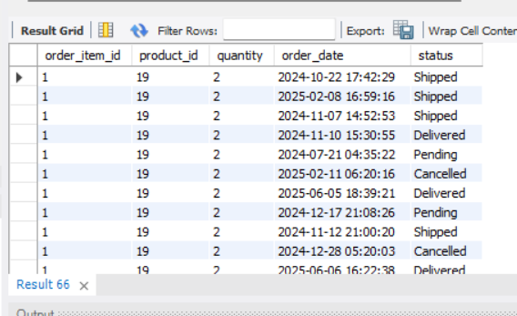
3. List all orders with their payment method (INNER JOIN)
select orders.order_date,orders.status,orders.total_amount,payments.method,payments.payment_id from orders
inner join payments on orders.order_id=payments.order_id;

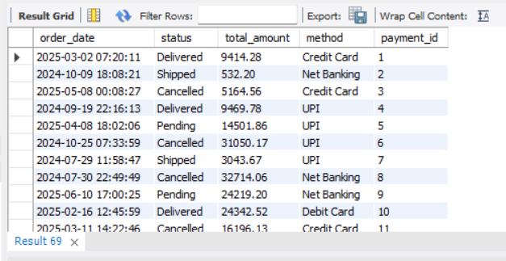

4. Get list of customers and their orders (LEFT JOIN)

select customers.name,customers.email,customers.phone,orders.order_id,orders.order_date,orders.status from customers
left join orders on customers.customer_id = orders.customer_id;

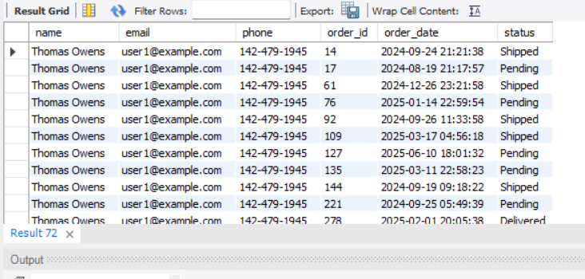

5. List all products along with order item quantity (LEFT JOIN)
select products.name,products.category,order_items.order_id,order_items.quantity,order_items.item_price from products
left join order_items on products.product_id=order_items.product_id;
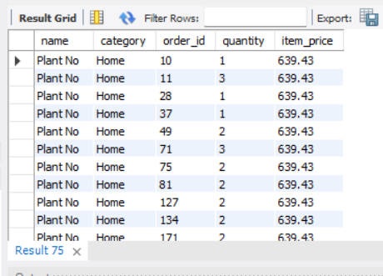

6. List all payments including those with no matching orders (RIGHT JOIN)

SELECT
p.payment_id,
p.order_id,
p.payment_date,
p.amount_paid,
p.method,
o.order_date,
o.status,
o.total_amount
FROM orders o
RIGHT JOIN payments p
ON o.order_id = p.order_id;

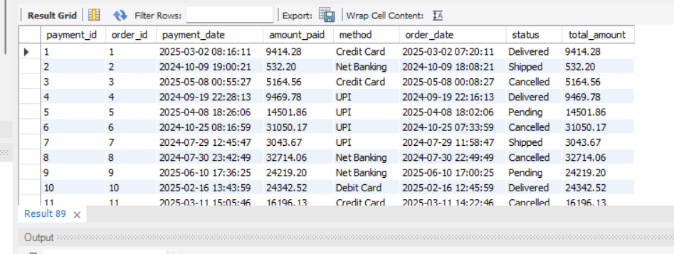
7. Combine data from three tables: customer, order, and payment
select payments.payment_id,payments.order_id,orders.order_id,orders.customer_id from payments
join orders on payments.order_id=orders.order_id
join customers on orders.customer_id=customers.customer_id;

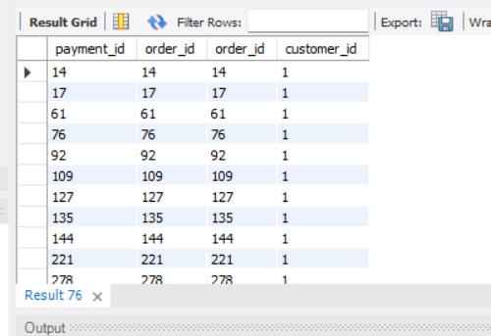

Level 5: Subqueries (Inner Queries)
1. List all products priced above the average product price
select * from products where price>(select avg(price) from products);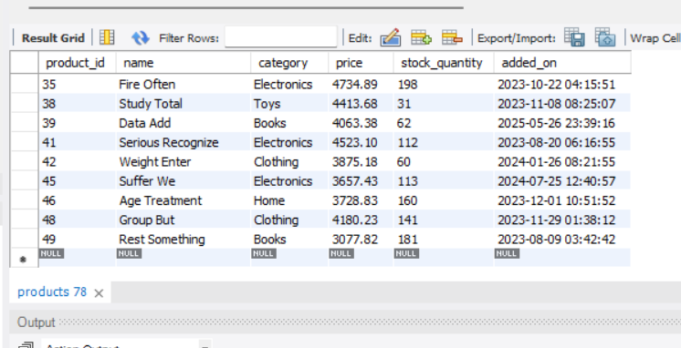
2. Find customers who have placed at least one order
SELECT DISTINCT
c.customer_id,
c.name
FROM customers c
INNER JOIN orders o
ON c.customer_id = o.customer_id;
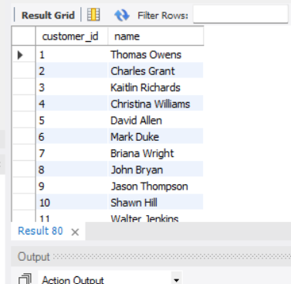
3. Show orders whose total amount is above the average for that customer

WITH customer_avg AS
(
SELECT
customer_id,
AVG(total_amount) AS avg_order_amount
FROM orders
GROUP BY customer_id
)
SELECT
o.order_id,
o.customer_id,
o.order_date,
o.total_amount,
ca.avg_order_amount
FROM orders o
JOIN customer_avg ca
ON o.customer_id = ca.customer_id
WHERE o.total_amount > ca.avg_order_amount;
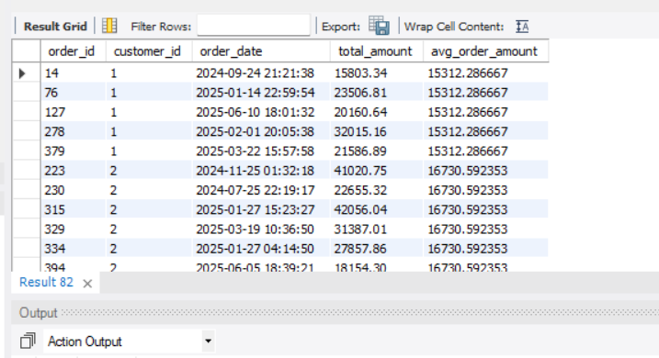
4. Display customers who haven’t placed any orders
SELECT c.customer_id, c.name, c.email
FROM customers c
LEFT JOIN orders o
ON c.customer_id = o.customer_id
WHERE o.order_id IS NULL;
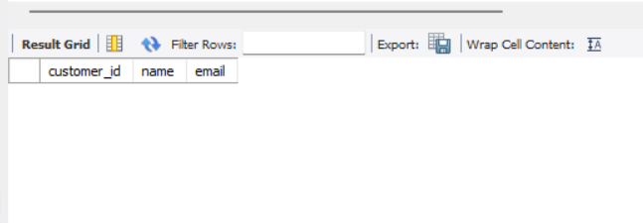
5. Show products that were never ordered
SELECT p.product_id, p.name
FROM products p
LEFT JOIN order_items oi
ON p.product_id = oi.product_id
WHERE oi.product_id IS NULL;
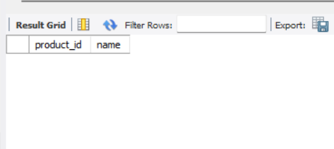
6. Show highest value order per customer
SELECT customer_id, order_id, order_date, total_amount
FROM (
SELECT
customer_id,
order_id,
order_date,
total_amount,
RANK() OVER (
PARTITION BY customer_id
ORDER BY total_amount DESC
) AS rnk
FROM orders
) x
WHERE rnk = 1;
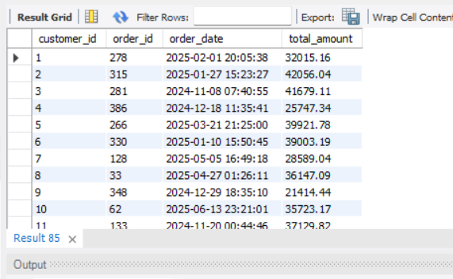
7. Highest Order Per Customer (Including Names)
SELECT
customer_id,
customer_name,
order_id,
order_date,
total_amount
FROM (
SELECT
c.customer_id,
c.name AS customer_name,
o.order_id,
o.order_date,
o.total_amount,
ROW_NUMBER() OVER (
PARTITION BY c.customer_id
ORDER BY o.total_amount DESC
) AS rn
FROM customers c
JOIN orders o
ON c.customer_id = o.customer_id
) x
WHERE rn = 1;
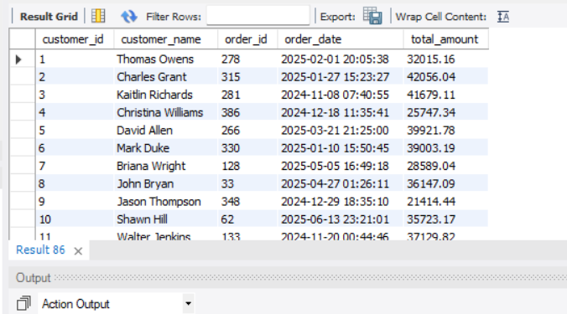
Level 6: Set Operations
SELECT customer_id
FROM orders

UNION

SELECT customer_id
FROM product_reviews;
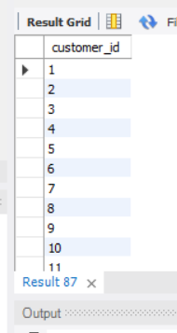

2. List all customers who have placed an order as well as reviewed a product [intersect not supported]

SELECT DISTINCT c.customer_id, c.name
FROM customers c
JOIN orders o
ON c.customer_id = o.customer_id
JOIN product_reviews r
ON c.customer_id = r.customer_id;
